Henzi Kou

CIS 471: Introduction to Artificial Intelligence

Prof. Thanh H. Nguyen

15 October 2019

Homework 1

1. Uninformed Search
   1. There are *7* nodes in the complete search tree for the state space graph.
   2. 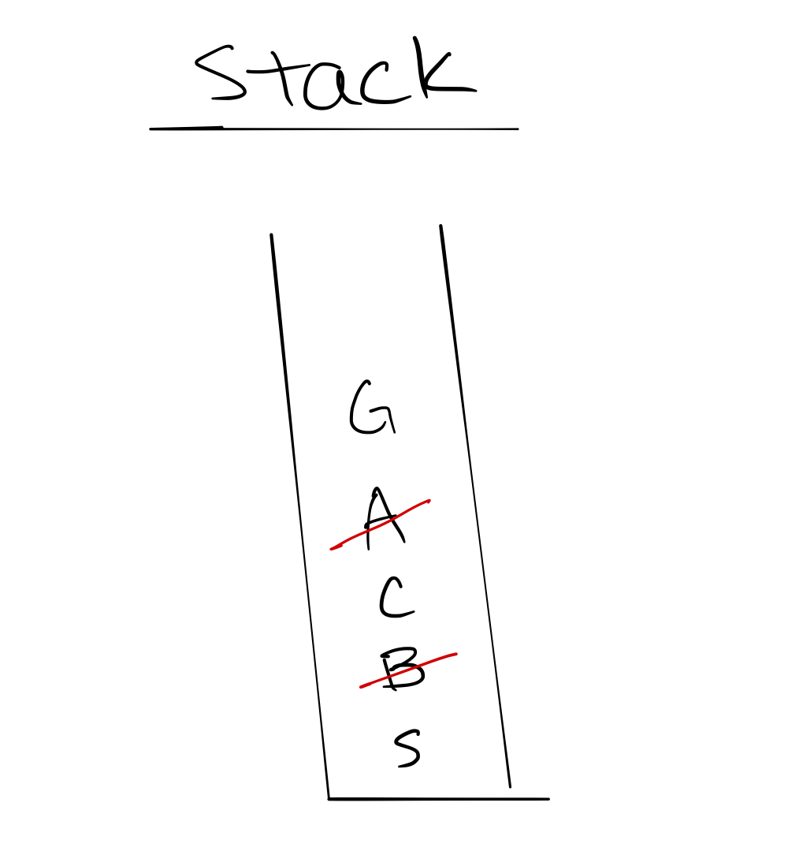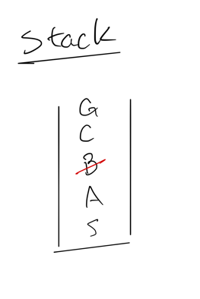Final path: *S* – *A* – *C* – *G*
   3. Final path: *S* – *C* – *G*
2. Informed Search
   1. 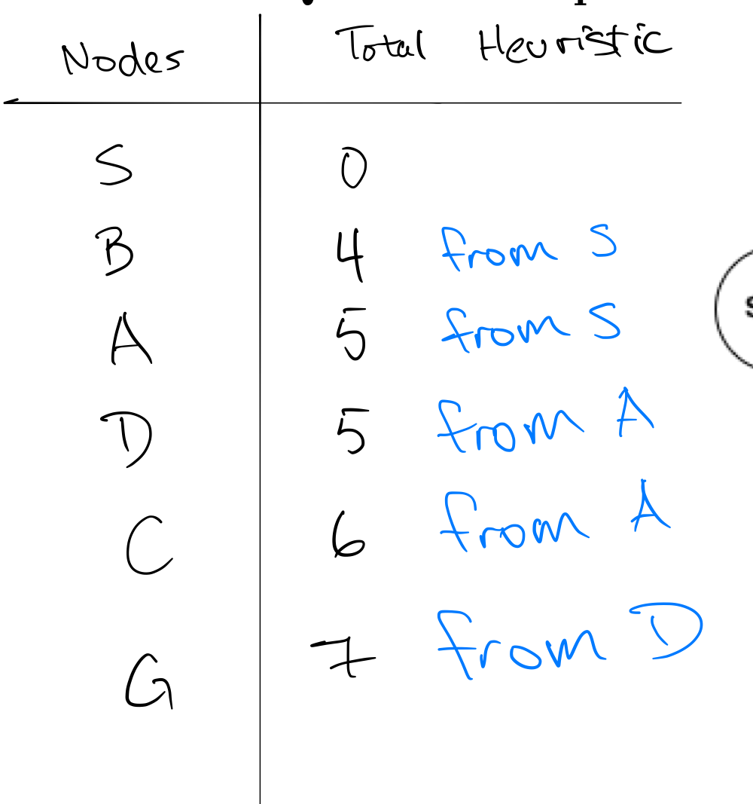Final path: *S* – *A* – *D* – *G*
   2. 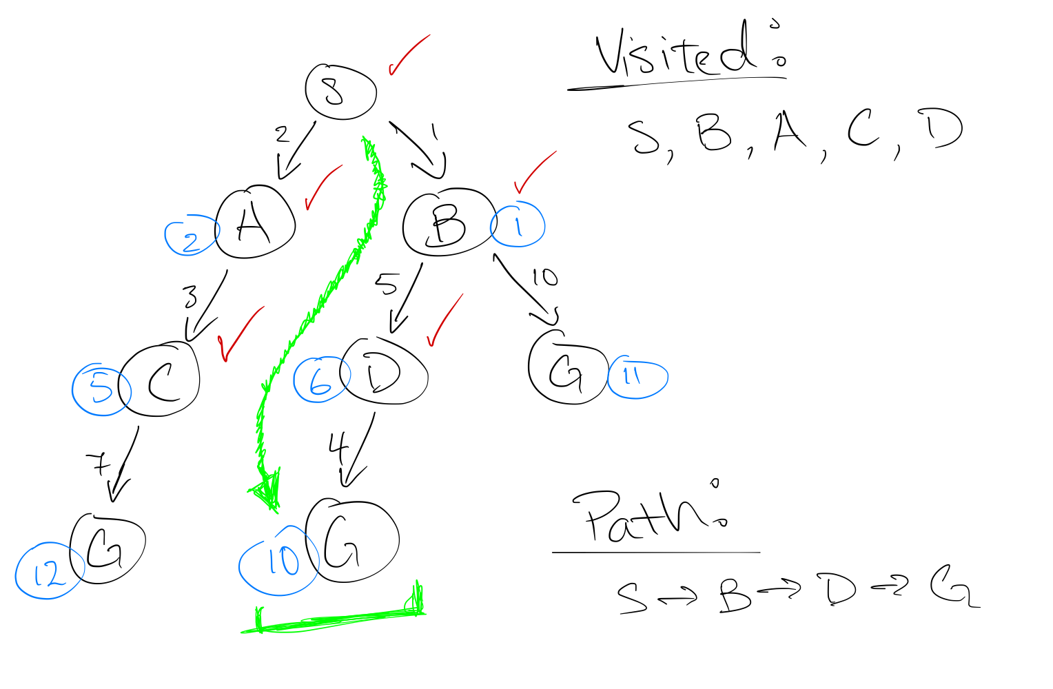Final path: *S* – *B* – *D* – *G*
3. Hive Minds: Lonely Bug
   1. 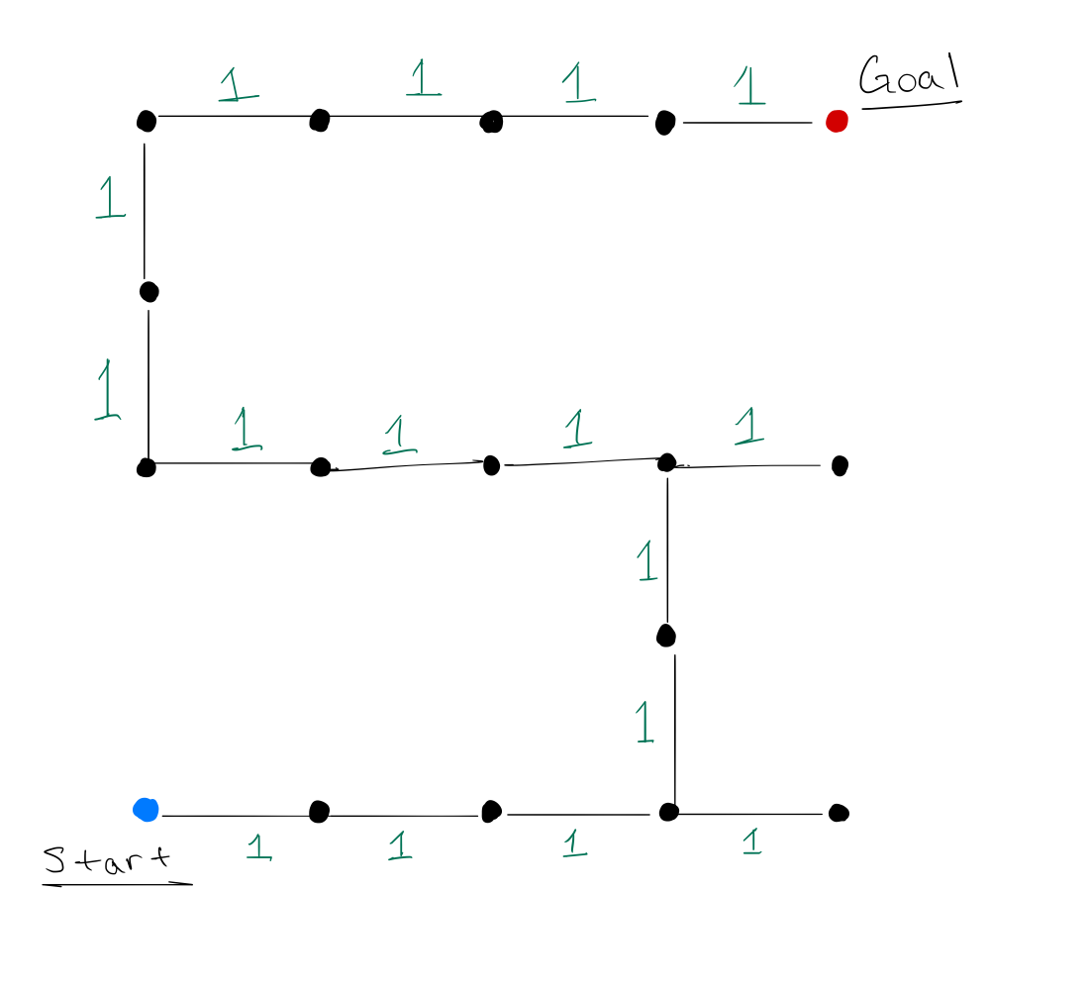We can use (*x*, *y*) to store the coordinates of the insect’s location at each instance. The size of the state space is thus $M*N$.
   2. Two admissible heuristics:
      * Measure the Manhattan distance between the insect and the target location.
      * Measure the Euclidean distance between the insect and the target location.
4. Hive Minds: Time Limit
   1. 2
   2. 8
   3. 8
5. Lookahead Graph Search
   1. Final path: *S* – *B* – *G*